**DOCUMENTATION FOR RHYTHMIC TUNES**

**1. Introduction**

* **Project Title: Rhythmic Tunes**
* **Team Members: DEPAK.G, HARISH.P, SHYAM.A, VENKATRAJ.J, SANJAY.S**

**2.Project Overview**

* **Purpose:** Rhythmic Tunes is a music streaming platform designed to provide a seamless experience for discovering, listening to, and managing music playlists. It aims to combine an initiative user interface with powerful search and recommendation features**.**
* **Features:**
* User authentication and profile management
* Music search and playlist creation
* Streaming music with playback controls
* Personalized music recommendations
* Offline listening support

**3.Architecture**

* **Component Structure:**
* Header Component – Displays navigation and user info
* Sidebar Component – Provides access to playlists and settings
* Player Component – Handles music playback and controls
* Search Component – Allows users to search for songs and artists
* Playlist Component – Displays user-created playlists and songs
* **State Management:**
* **Global State:** Managed using Redux Toolkit for centralized state management
* **Local State:** Managed within components using the useState and useReducer hooks
* **Routing:** Uses react-router-dom for navigation between pages (e.g., Home, Search, Playlist)

**4. Setup Instructions**

* **Prerequisites:**
* Software Requirements:
* Node.js – JavaScript runtime environment
* npm – Package manager
* React.js – JavaScript library for building user interfaces
* **Installation:**
* Install Node.js and npm:
* Download Node.js
* Create a new React app using Vite:
* npm create vite@latest
* Navigate to the project directory and install dependencies
* cd project-name npm install Start the development server
* npm run dev
* Open the app in the browser
* <http://localhost:5173>

**5. Folder Structure**

src/

├── components/

│ ├── Header.js

│ ├── Sidebar.js

│ ├── Player.js

├── pages/

│ ├── Home.js

│ ├── Search.js

│ ├── Playlist.js

├── assets/

├── hooks/

├── utils/

├── state/

└── index.js

**6. Running the Application**

**Start the React application:**

**npm run dev**

**Start the JSON server:**

**json-server --watch ./db/db.json**

**Open the app in the browser:** [**http://localhost:5173**](http://localhost:5173)

* **Frontend:**
* React.js – For building the user interface and state management.
* React Router Dom – For navigation and routing.
* React Icons – For embedding icons.
* Bootstrap/Tailwind CSS – For styling components.
* Axios – For HTTP requests and data fetching.

**8. State Management**

* **Global State:** Managed using Redux Toolkit for centralized state management
* **Local State:** Managed within components using the useState and useReducer hooks.

**9. User Interface**

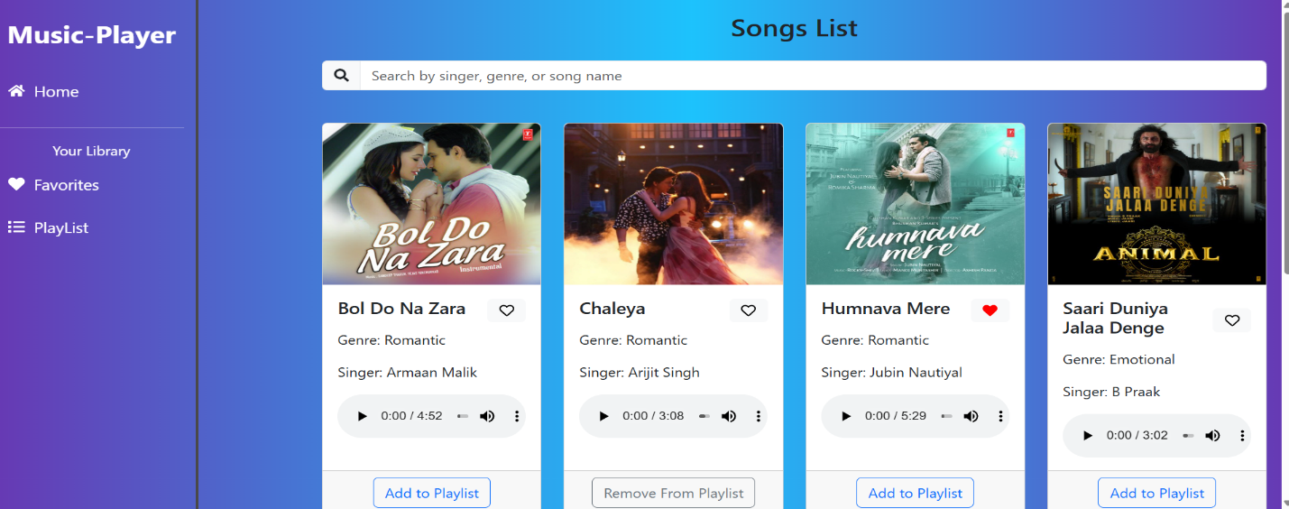

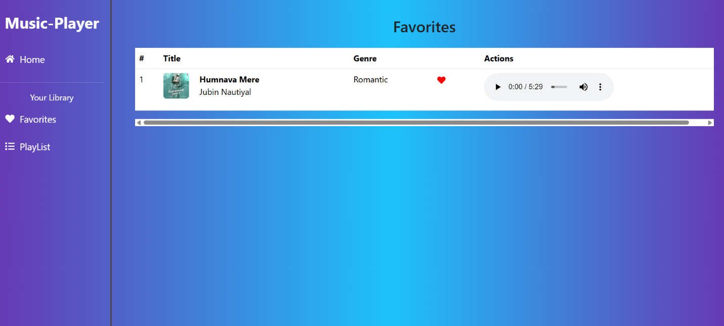

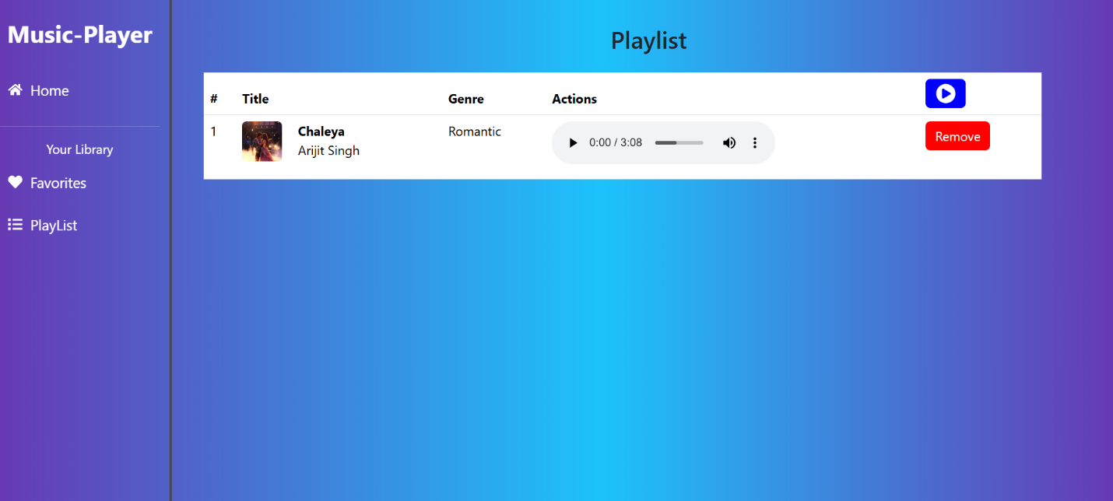

**10. Styling**

* **CSS Frameworks/Libraries:** Tailwind CSS for component styling Custom themes defined using CSS variables
* **Theming:** Dark mode and light mode available Testing

**11. Testing**

* **Testing Strategy:** Unit testing with Jest Component testing with React Testing Library
* **Code Coverage:** Code coverage tracked using Jest

**12. Project Link**

* **Link: https://github.com/deepak-1401/music-.git**

**13. Known Issues**

Issues

Playback stuttering on slow connections

Minor visual bugs in dark mode

Future Enhancements

Add social sharing for playlists

Integrate lyrics display feature

Implement a recommendation algorithm based on listening habits

**14. Future Enhancements**

* Rhythmic Tunes is a dynamic and interactive music streaming platform designed to provide a seamless and engaging user experience. Its use of modern web technologies like React.js ensures a fast, scalable, and responsive application.